Creative Gesture Input: Webcam-based Pose-Controlled Racing Game Interface
- Introduction
…
- Objectives
This project aims at developing a Python application that utilizes webcam to capture human body poses, and translating detected poses into controller inputs to operate a racing game, such as Horizon4, to create a hands-free, immersive gaming experience. The project creates a novel interactive means for game input, whose system mainly contains four sequential objectives:
- Implement real-time pose detection using machine learning models on pictures captured using webcam.
- Process detected gesture data and map specific body movements (e.g., leaning, arm gestures) to racing game controls (steering, acceleration, braking).
- Create a user-friendly interface for tuning gesture data processing and control mapping.
- Integrate with a virtual controller (gamepad emulator) for testing and demonstration.
3. Technologies and Tools
- Python as programming language.
- OpenCV for webcam video capture and image processing.
- MediaPipe as pose estimation library.
- vgamepad for gesture and game control mapping.
- Tkparam/Pygame for user interface building.
4. Key Features
- Real-time pose detection and tracking.
- Customizable mapping of poses to game controls.
- User calibration and setup interface.
- Visual feedback for detected poses and control inputs.
- Scalable module-based system framework for future expansion.
5. System Overview
Our system consists of three modules. Pose detection module obtains real-time pose landmark data and pass to Gesture mapping module, where the data are processed for triggering distinct control inputs in the virtual gamepad. During the process, a graphical user interface is setup for parameter calibration and detection visualization.
- Main system: Maintaining the main loop which handles picture capturing and application event.
- Pose detection module: Apply OpenCV and MidiaPipe for upper body pose detection, obtaining real-time pose landmarks at a frame rate of 30.
- Gesture mapping module: Process pose landmarks and trigger corresponding game control inputs in vgamepad emulator, composed of multiple sub-modules for specific control input triggering.
- GUI: Controls landmarks processing parameters and visualizes detected control inputs.
The chart below demonstrates the details of our system.
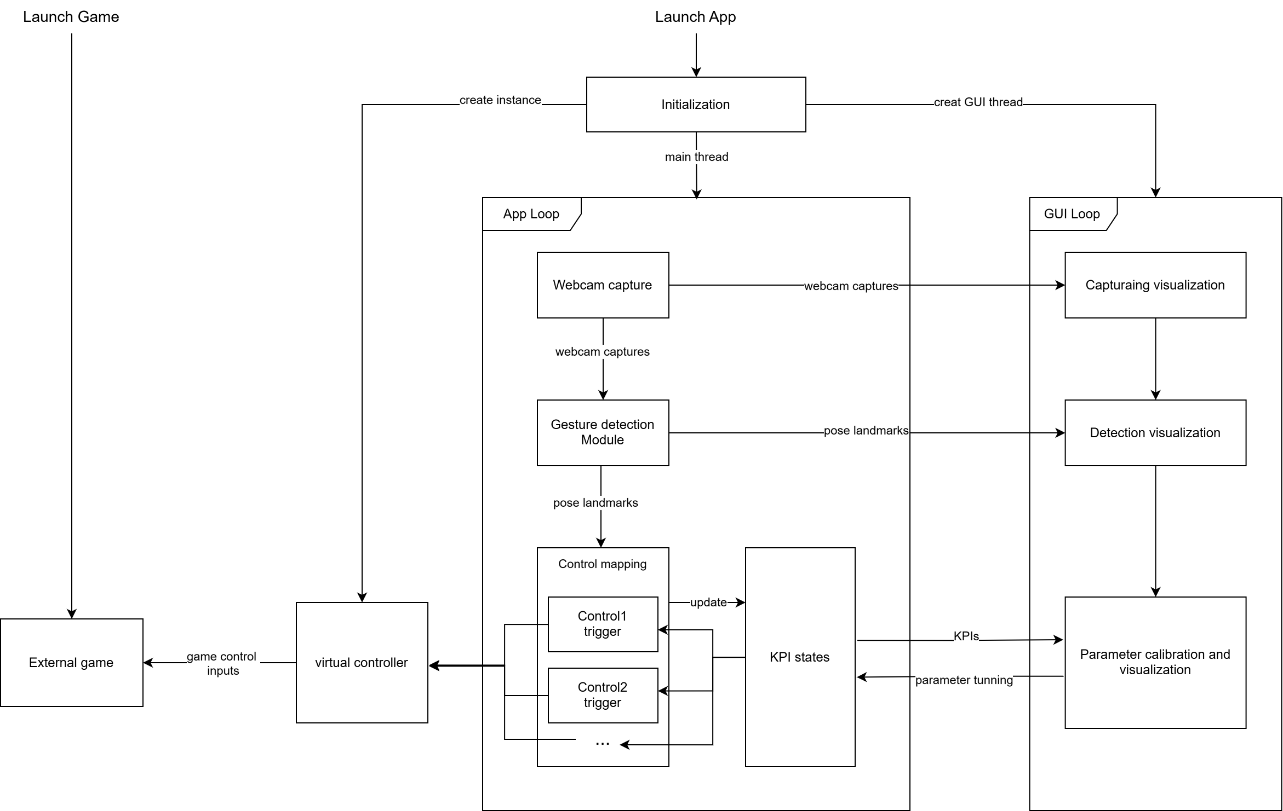
6. Expected Outcomes
- Functional prototype, a Repo on Github, enables pose-based control of the racing game, Horizon4.
- Demonstration video showcasing hands-free gameplay.
- A Readme file for setup, usage, and further development.
7. Challenges
- Achieving accurate and robust pose detection in various lighting conditions.
- Ensuring low-latency and smooth input for responsive gameplay.
- Mapping complex poses to intuitive game controls.
8. Future Extensions
- Support for additional games and genres.
- Multi-user pose detection for competitive or cooperative play.

